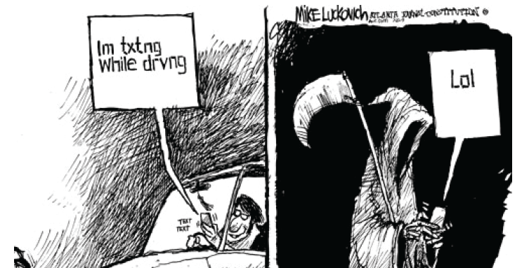

Audience: Who is the audience?
Purpose: What is the argument / message?
Tone: What stance did the author take?
Genre and Medium/Design: What visual images relay the argument?
Context: What are the issues or circumstances surrounding the message?
What are the persuasive appeals used? How are they effective on the audience?
What other visual techniques are used and how are they effective?

